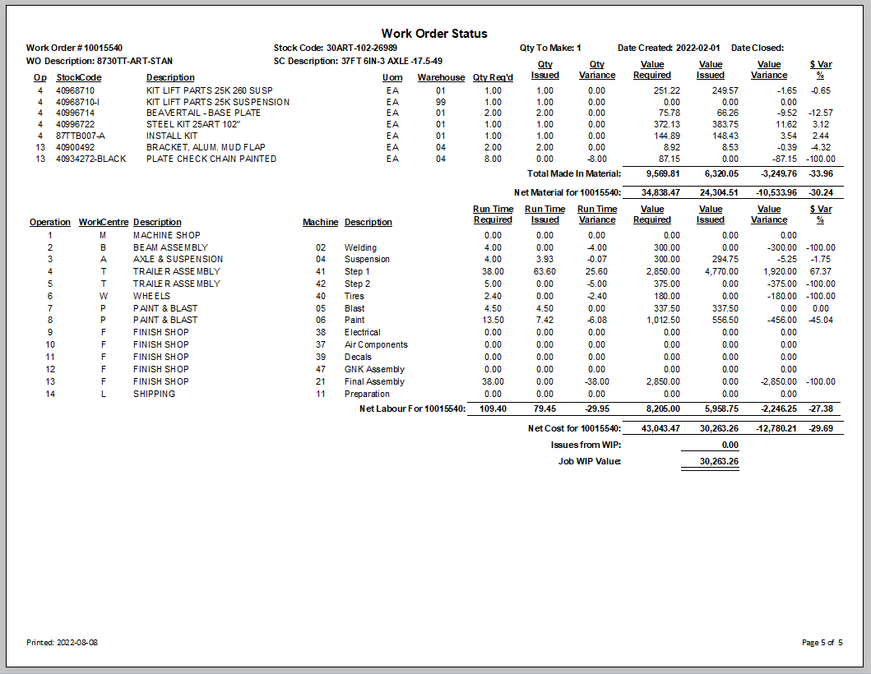
Description of the stock code being made.
This is the stock code being made by this work order.
Work order number.

Date the work order was closed. If blank I is still open and in process.
Date the work order was first made.
Material, sub total bought out, made in, sub contact.
Made in subtotal.

